PRECESSION OF EQUINOXES
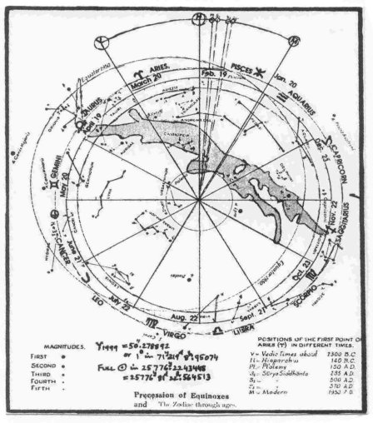
"Precession of Equinoxes: EQUINOX – equal night, is the time of the year when the center of Sun is directly over the equator. The Sun crosses the equator twice during a year: (a) Vernal (spring) equinox, March 21/22, as the Sun enters Northern hemisphere; and (b) Autumnal (autumn) equinox, September 21/22, as the Sun enters Southern hemisphere. PRECESSION: Since the center of Sun does not always cross the equator at the same equinoctial point, each year the Sun crosses the equator about 50-seconds (Y2000=0.013966486°) of arc-angle, west of the point where it crossed the year before – or 1° in 71.59997153 years. This westwards movement of the equinoctial point is called Precession of Equinoxes. The attraction of the Sun and Moon upon the equalitarian bulge of earth causes the Earth's equator to change in regard to apparent path (ecliptic) of the Sun, across the sky and the ‘celestial equator’ (an equivalent of terrestrial equator in space). This attraction is called luni-solar precession, since caused by LUNA (Moon) and SOL (Sun). Every year it causes the Earth to twist slightly to the east, so that Sun appears to be moving west. If Sun and Moon were the only influences on earth's precession: the vernal equinox would move 50”. 27935 + 0.000229 T per year, where T is number of years after AD 2000 of arc per year. But, other planets also exert a pull that cause an eastward movement of 0.1”/year – called planetary precession. Because the whole Earth twists as a unit, the North Celestial Pole - point in the sky above earth's North Pole - swings in a large circle among the stars in the same period of time. The brightest star within a few degrees of arc of this circle becomes the Pole Star for thousands of years, while the North Celestial Pole is in its vicinity. Because of precession, Zodiac signs no longer correspond to the constellation for which they were named - Aries. In 2000 years, the First Point of Aries/Mesha is now in Pisces/Mina and is receding to Aquarius/Kumbha. This means that it will take25775y 361d 11h.97585916 for the precession of equinoxes to take one full circle, at current rate of precession".

