World Calendar Format & Divide by SIX (6) Leap Weeks
An 834-year span shall have 304611.9937836 days, to account 148 ‘leap weeks’. All years shall have 52 weeks, OTHER THAN THOSE YEARS DIVISIBLE BY SIX (6), which shall have an added 53rd week as ‘Leap Week of the Year XXXX’. In addition, only NINE (9) additional leap weeks, need be included at a frequency of (87,90,96,90,96,90,96,90,96) years − except only the first three (3) years earlier (during 87th year); since 834th year (i.e. year 2838) itself happen to be divisible by SIX (6).
An ‘over- accounted’ error of only ONE DAY shall creep into after a long span of 134161.2508728 years (134161 years 91 days 15.10399407 hours). A 2x(90+96)-year cycle has 135870.094568 days (19410.0134 Weeks) to take care of 4600.9958 Lunation; 4972.9805 Sidereal Moons and 4992.9804 draconic months of Moons.
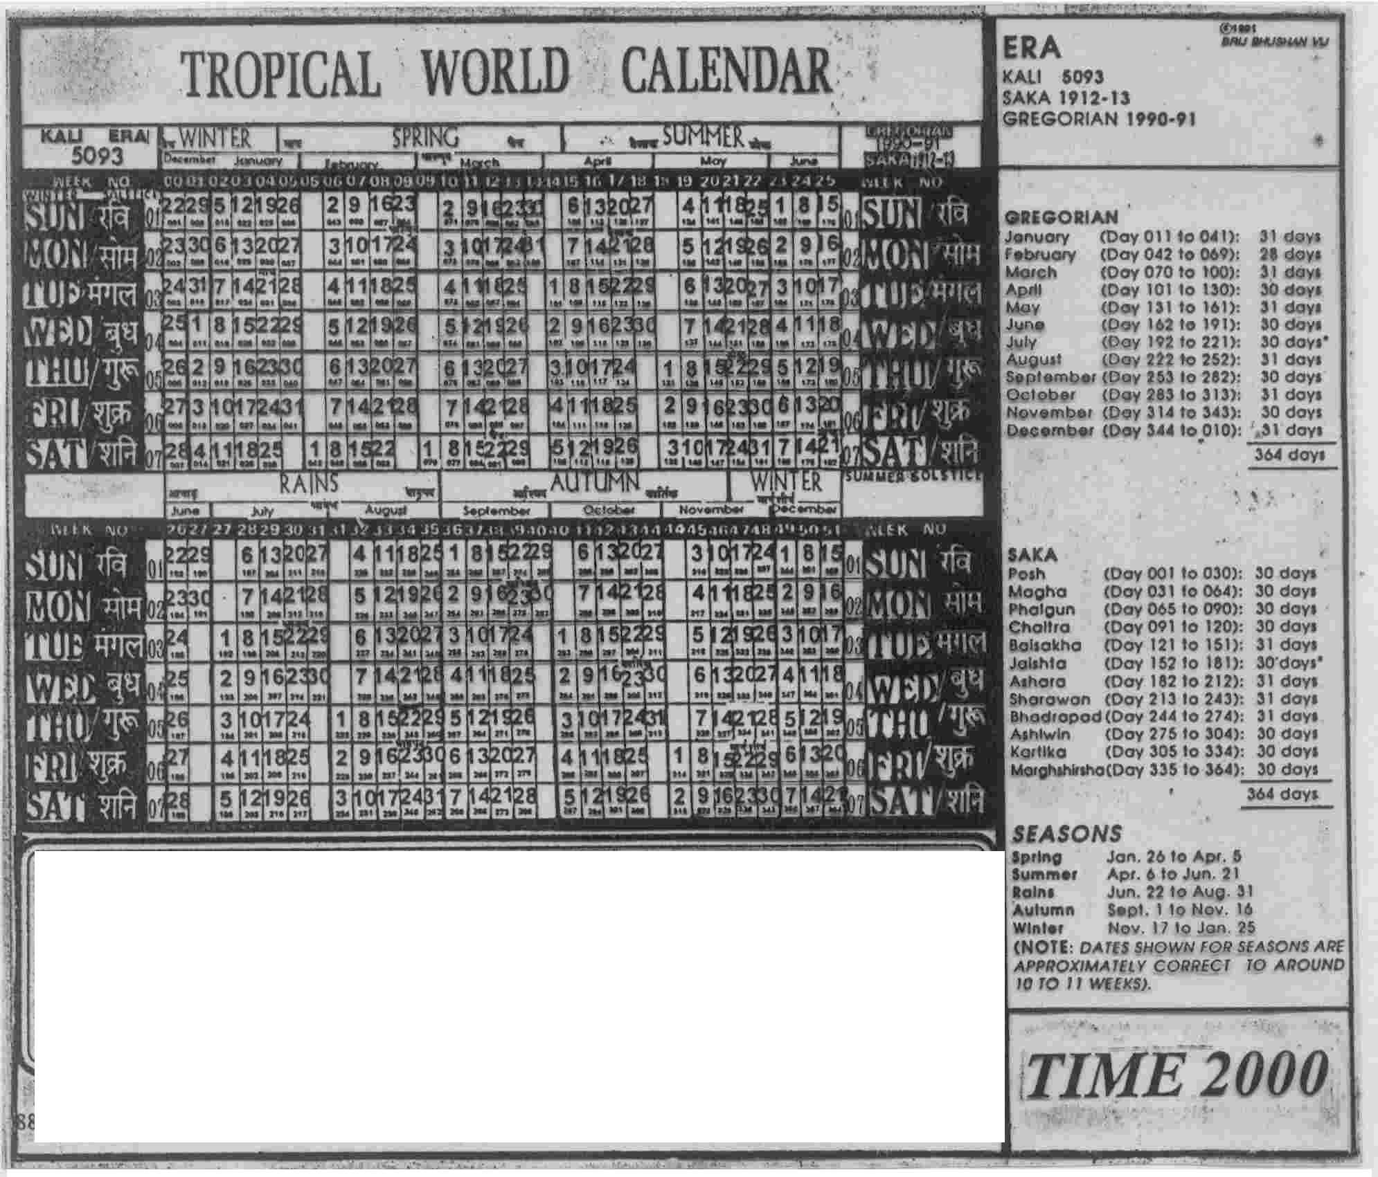
THE LEAP WEEK RULE: (834 yrs/148 L Ws: Reworked)
As against this, the Gregorian calendar accumulates such error of 1 day in 3319.846457 years (or about 3320 years). Each day shall have 24h x100m_{d} x100s_{d} (or 240000 atomic seconds) during the day. The ‘TIME interval’ second is defined as:
DEFINITION: ONE DECIMAL SECOND (s_{d}) is the time interval between any TWO events that take place during the fraction 1/240000th of the atomic day (of 86,400 atomic seconds) and correspond to 3309347437.2 periods of radiations of cesium-133 atom, at defined hyperfine levels, when the atom is at rest.
This is 36 % of the SI-second; or 1/87658125.52075th of the modern astronomers’ mean tropical year Epoch basis VSOP82, on AD 2000.00.

